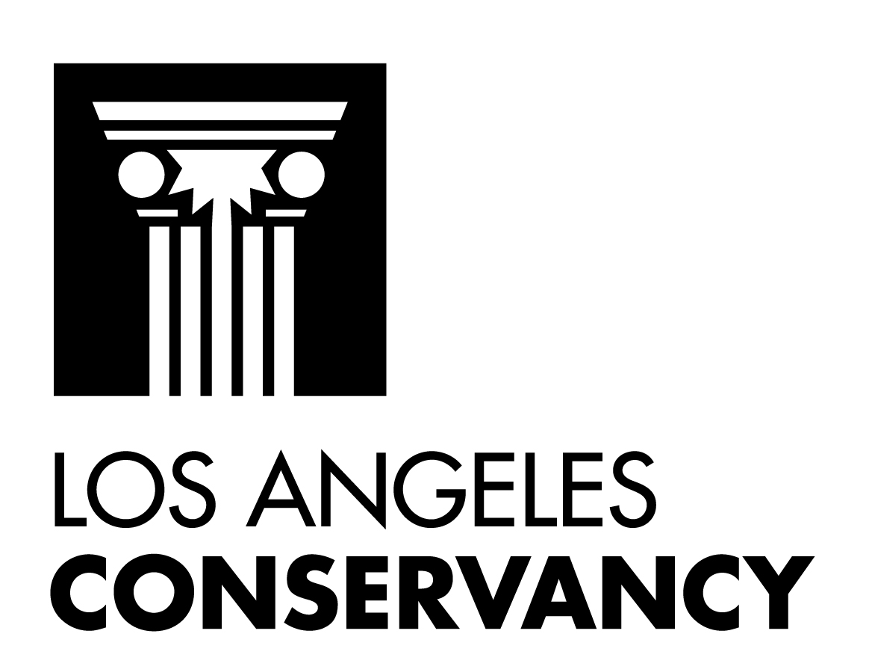

LETTER OF INSTRUCTION - GIFT TO The Los Angeles Conservancy

I have designated THE LOS ANGELES CONSERVANCY as a beneficiary to receive ______________________(specify dollar/percentage amount) from my

will or trust, being handled by __________________________________ (specify name of managing financial institution) at the end of my lifetime.

Or: I have designated THE LOS ANGELES CONSERVANCY as a beneficiary to receive

______________________(specify dollar/percentage amount) from my

_________________________ (IRA, Insurance, Other Account – please specify

details).

Current Contact information for my attorney or financial advisor is:

Name:________________________________________________________

Address: ______________________________________________________

City/State/Zip: __________________________________________________

Phone: ______________________ E-Mail: ________________________

_______________________________
Name of donor (please print)
_______________________________
Signature of donor

________________________________
Date

RECEIVED AND ACCEPTED this _______ day of _______________, 2014.

THE LOS ANGELES CONSERVANCY

By: __________________________________

Title: _________________________________

Questions/Contact:

Liz Leshin
Director of Development
Los Angeles Conservancy
523 W. 6th St., #826
Los Angeles, CA 90014
Direct Line: (213)430-4213

2/5/25

